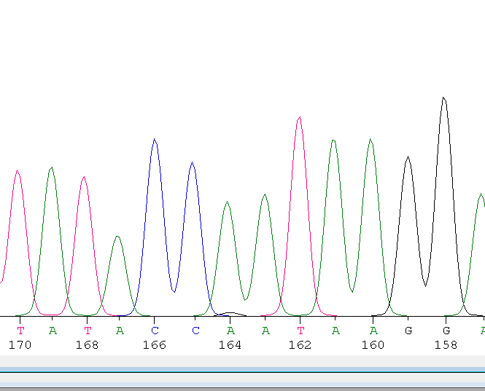

G123-166

G/A AT het

Obvious on plate

1 of 2 AAT (N)

GAT (D) not one of the amino acids in data set